___________________________________________________________________________________
Hillside Primary School and Nursery
Belstead Avenue Ipswich Suffolk IP2 8NU
Telephone: (01473) 601402 Email: office@hillsidecp.net
Website: www.hillsidecp.net
Headteacher: Mr Lee Abbott BA (Hons) QTS NPQH

“We are learners, nurturing learners for a bright future”
_____________________________________________________________________________________

October 2019
Year 5 Bawdsey Residential Trip July 2020
Where is it? | Bawdsey Manor,  Suffolk  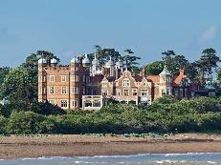 | When is it? | Summer Term  Monday 6th July 2020 – Friday 10th July 2020
Where do the children stay? | Hard based tents  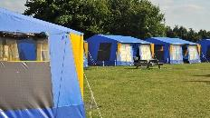 | Who will go? | Year 5 Children (ONLY 50 PLACES!)  6 Hillside Staff
What activities are there? | A range of action packed activities | Health and Safety | Full Risk Assessments High Staff-to-pupil ratio  PGL ‘Groupie’ for each group  Staff vetting (DBS) & training  24 Hour Site security  First Aid procedures  Emergency Procedures
How much will it cost? | TOTAL COST £335.00  £50 non-refundable deposit by 31st October 2019  Followed by 1 payment of £40 and 7 payments of £35  Total balance to be paid by June 2020 | What if money  Is tight? | The Northgate Fund is available to provide financial support so that as many children can go.  Parents make a contribution,  Northgate pay the balance! Ask at the office for more information.
Where can I find out more?
www.pgl.co.uk/en-gb/school-trips/resources/parent-guide/about

Year 5 Bawdsey Residential Trip
6th July 2020 – 10th July 2020

Child’s name ____________________________________________ Class ____________________

I consent for my child to attend the Bawsdey Residential Trip and enclose a £50 non-refundable deposit.

I agree to pay monthly instalments as follows:

1 x payment of £40 and 7 x payments of £35.

Parent’s Name _________________________________ Parent’s Signature _____________________

Contact Telephone Number _____________________________________________

